Green Communities Carbon Neutral Framework
Option 1: Project Profile
Organic Waste Composting
Project Profile Overview
This project profile provides guidance on estimating the amount of greenhouse gas (GHG) emissions that can be reduced by diverting organic waste into a centralized community composting system rather than sending it to a landfill. When organic waste is placed in a landfill it decomposes gradually over decades and creates a significant amount of methane due to the absence of oxygen. In contrast, when organic waste is composted it decomposes within one year and predominantly creates carbon dioxide because oxygen is made available.
Because methane is 25 times more potent than carbon dioxide on a 100-year global warming potential basis, composting can reduce GHG emissions by over 90% in contrast to sending the same waste to a landfill. These reductions are dependent on the type of organics diversion project and the efficiency of a landfill gas collection system.
Management practices and systems for centralized composting programs have had many years of advancement in communities of all sizes across North America. Composting systems that local governments can choose from include turned windrows, covered aerated static piles and in-vessel composting. See the “Technology Options Overview” section for further information on composting systems that are eligible under this profile.
There are many composting technology options that vary in terms of complexity and the kinds of organic waste that can be processed. This project profile category does not cover anaerobic digestion—a contained process that produces a gas that can be combusted to generate heat and / or power—due to the complexity of assessing emission reductions. Backyard composting is also not covered by this project profile because of the onerous data collection and administration challenges associated with a very large number of small systems that would be difficult to monitor.
Although the exact number will vary by community, this project profile estimates that every tonne of organic waste that is diverted from a typical landfill (with a landfill gas capture system) into a centralized composting system will result in roughly 0.4 of a tonne of GHG emission reductions. Note that this is a very rough estimate that will change depending on the type of composting project and based on a number of community factors. Organic waste that is diverted from small landfills that are not required to have landfill gas capture systems could result in significantly greater GHG reductions. Specifically, an existing or planned landfill gas capture system at the landfill site will decrease the emission reduction potential, and this is discussed in more detail below.
Calculating Emission Reductions
When organic waste is placed in a landfill, methane emissions occur gradually over 100+ years as the material decays (Baseline Emissions). In contrast, placing the same amount of organic waste in a centralized composting facility involves a rapid aerobic decay that generates far fewer emissions within a single year (Project Emissions). So when organic material is composted instead of going to a landfill, there is a reduction of emissions that would have occurred at the landfill in the future. This project profile provides an accounting approach to measuring these reductions over time in each year that they would have occurred.
Project Example:
The following example illustrates the steps needed to estimate the Net Emission Reductions associated with diverting organic waste out of a landfill and into a basic forced aeration centralized composting facility. This is a hypothetical example meant to illustrate the potential GHG savings from a fictitious organics diversion project.
In 2012, a local government implements an organic waste composting system that diverts 300 tonnes of kitchen scraps and 300 tonnes of eligible yard waste out of a landfill that has a gas capture rate of 50%. In 2016, this example landfill is assumed to upgrade their gas capture rate of 75% (in line with the Landfill Gas Management Regulation – described in the next section) for the remainder of the life cycle calculations. Using this example, the figure below illustrates the Baseline Emissions that would have occurred if the waste was sent to a landfill represented by the blue bar. In contrast the red bar represents the Project Emissions that would be generated by instead diverting the 600 tonnes to a basic forced aeration centralized composting facility. The green bar represents the Net Emission Reductions of 403 tonnes, which is equal to the Baseline Emissions (475 tonnes) represented by the blue bar minus the Project Emissions (72 tonnes) represented by the red bar.
Illustration of the Net Emission Reductions from diverting 300 tonnes of kitchen scraps and 300 tonnes of yard waste from a landfill into a centralized composting facility in 2012.
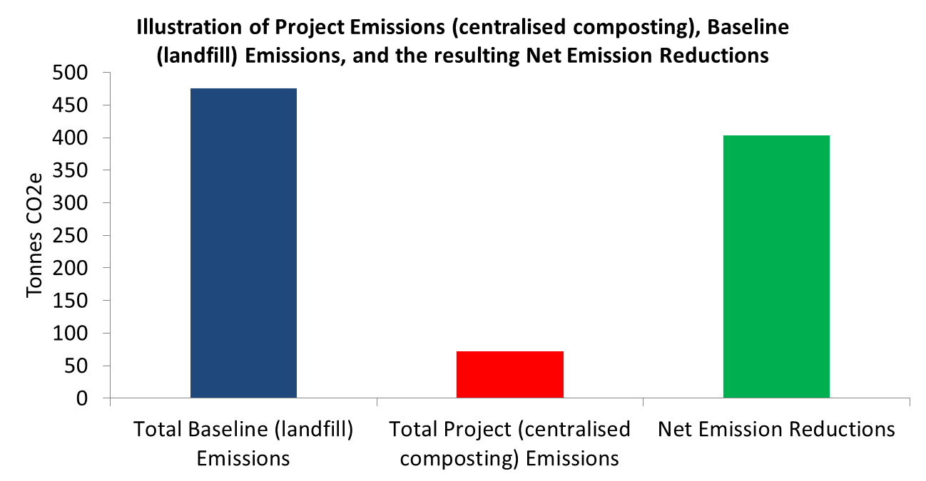
The example above illustrates the Net Emission Reductions of 403 tonnes achieved from diverting organic waste in one year only—2012 in this example. The process would be repeated for each year that a project is in place. To ensure that lifecycle emission reductions are properly accounted for, the Total Baseline Emissions extrapolate 100 years of emissions that would have occurred at a landfill. This approach is consistent with offset protocols for organic waste diversion developed by Alberta and the U.S. EPA Landfill Gas Emission LandGEM Model.
Landfill Gas Capture and the Landfill Gas Management Regulation
This project profile requires an estimate of the amount of landfill gas that is captured at the local landfill. This is because landfill gas capture reduces the baseline emissions, and will therefore reduce the amount of reductions that can be achieved with a centralized composting example. As an extreme example, if the local landfill has 100% landfill gas capture there would be no opportunity to reduce emissions with a centralized composting system. This is because all of the methane associated with sending the organic material to the landfill would be captured and turned into carbon dioxide via combustion. This is an illustrative example only as 100% landfill gas capture is currently not practical.
Landfill gas capture systems reduce landfill emissions by capturing methane and then combusting it to create energy and carbon dioxide. Combusting one tonne of methane generates one tonne of carbon dioxide, which is approximately a 95% reduction in landfill emissions. Due to this reduction potential, landfill gas capture is an effective and relatively low cost method of reducing GHG emissions.
The Landfill Gas Management Regulation requires all landfills that generate 1,000 tonnes or more of methane annually to have (1) a landfill gas management facilities design plan and (2) to install the designed landfill gas management facilities outlined in the plan within four years of submitting the design plan. In order to calculate the baseline emissions in any given year, the organics diversion calculator (ODC) requires a landfill gas capture rate for the current year, and for the succeeding 100 years. These projected landfill gas capture rates will be based on landfill design plans and provincial regulations such as the Landfill Gas Management Regulation. The ODC provides guidance on how this should be done.
The ODC simplifies the calculations needed to determine the annual emission reductions associated with a centralized composting facility for household organic waste. The baseline year is 2006 and any organics diversion that occurred post signing of the Climate Action Charter (September 2007) is eligible for credits.
Ownership of Credits (Updated April 2015)
To be eligible to claim GHG emissions reductions credits resulting from organic waste composting projects, local governments must be able to demonstrate ownership of GHG emission reductions. If a local government uses their municipal fleet vehicles to collect organic material, ownership of GHG emissions reductions is implied. If they are using a private hauler to collect organic material, ownership should be established between the contracting parties using explicit language contained within the service agreement.
In the case where a local government establishes an incentive program for organics diversion, and organics are collected by waste haulers under this program, the provider of those incentives may be in a stronger position to claim a portion of any GHG emissions reductions credits. Ownership must be established using explicit language contained within the incentive agreement. Such contract language may include, “Waste haulers, as a condition of providing organics collection services/participating in the rebate incentive program, acknowledge that (insert local government/regional district) reserves the right to retain and/or distribute all greenhouse gas reduction benefits that are associated with the organics diverted by this service/this program”
Spreadsheet directions
Note: Macros must be enabled for the spreadsheet to function properly.
Step 1: Total organic material diverted
Enter the net additional organic material (tonnes) for kitchen scraps and yard waste beyond the 2006 baseline that is diverted out of the landfill and into the centralized composting system. | This value will require either direct measurement or an initial defensible estimation methodology. A provincial estimation methodology has not been supplied due to the complexities that exist on a local government by local government basis.
Step 2: Project type
Enter the composting facility project type. | See spreadsheet for a listing of project types. In the “project emissions” tab a detailed explanation of composting facility project types and their corresponding emission factors exists.
Step 3: Landfill Gas Collection Efficiency
Enter the % of landfill gas that is captured for each year that is being assessed. | Discuss with landfill operator. All large landfills are required to report the landfill gas collection system collection efficiency annually under the Landfill Gas Management Regulation. A projection of landfill gas capture % 100 years into the future must also be made to calculate instantaneous 100 year avoided emissions. Note after 2015, collection efficiency will be locked at 75% in line with the Landfill Gas Management Facilities Design Guidelines.
Step 4: Landfill Location
If your local landfill is not listed in the spreadsheet, select a landfill with similar annual precipitation. | See spreadsheet for a listing of landfills.
Note: Once the information from 1, 2, 3 and 4 is entered into the spreadsheet in the “T1-Inputs” tab, the Baseline Emissions (emissions avoided), Project Emissions, and Net Emission Reductions (emissions you can claim) are automatically calculated. To ensure conservative estimates with a first order decay model, the Clean Development Mechanism suggests a correction factor of 0.9 be applied to correct for model uncertainties. This correction factor has been applied to all estimates under the GGC first order decay model.
Carbon Neutral Framework Compliance
The following checklist outlines seven Project Eligibility Requirements under the Carbon Neutral Framework. Option 1—GCC Supported Projects — are already considered to meet Project Eligibility Requirements three and four below. To demonstrate how an Option 1 project meets the five remaining eligibility requirements, simply complete and make public an Option 1 Project Plan Template (see Appendix 6 of the Becoming Carbon Neutral guidebook).
Prior to completing the Option 1 Project Plan Template, local governments should refer to section 2.1.1 and Appendix 1 of the Becoming Carbon Neutral guidebook.
Checklist:
- Emission reductions are outside of the local government corporate emissions boundary
- Emission reductions have occurred before they are counted
- Emission reductions are credibly measured
- Emissions reductions are beyond business as usual
- Accounting of emission reductions is transparent
- Emission reductions are only counted once
- Project proponents have clear ownership of all emission reductions
Technology Options Overview
Composting technologies vary in terms of complexity and the kinds of organic waste that can be processed. Another option (not currently part of this calculator) is anaerobic digestion that produces a gas that can be combusted to generate heat and / or power, providing a revenue stream and displacing additional GHGs. Backyard composting is not featured (despite potential for even lower emissions) because of the onerous data collection challenges, and the typically lower rates of penetration.
Technology ª | Type of feedstock | Typical Capacity | Processing duration | Typical capital cost  ($ /tonne of waste annual capacity) | Typical operating costs  ($/tonne of waste input) | Sample  Technology | Issues
Compost: Turned windrows | Yard and garden waste, typically no food waste | Can be any size. Limited by space available | 6 to 12 months | 75 | 40 | No proprietary technology. 100s of plants in North America. Well understood, mature. | Process is accessible to vectors and climate. Labour, space and time intensive.
Compost: Covered Aerated Static Piles | All | 20,000 tonne per year modules | 3 to 6 months | 250 | 40 | GORE™ Cover system with plants in Edmonton, Toronto, Seattle, Chemainus, and 100s worldwide.  Variations include AgBag, Dupont, Texel | Covers not using breathable membrane require odour management. Cold winter conditions may slow processing time since piles are outside.
Compost: In-vessel | All | 10,000 to 200,000 tonnes per year | 3 to 6 months | 300 to 550 | 50 to 100 | Wide variety of technologies, e.g., Bedminster, Ebara, Wright, ICC. Facilities in place in Comox, Nanaimo and Whistler. | Most operate well, but there may be operational problems with odours related to material handling and corrosion of interior structure.
ªIncludes a range from basic to optimized technologies – please refer to the project emissions tab in the Organics Calculator.
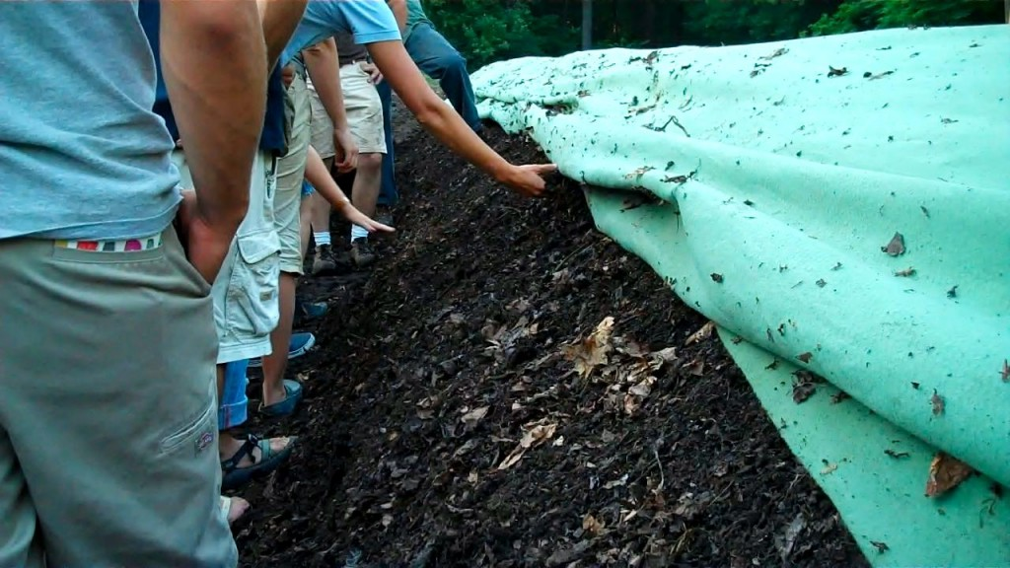
Design Considerations
- There is a diversity of technologies suiting projects of different scales and other conditions. Capital and operating costs, as well as revenue potential vary widely. The most capital intensive is anaerobic digestion, rather than composting. It also generates a biogas which can be combusted to generate heat and power, digestate by-product that can be composted and used as a soil amendment, and wastewater that must be managed and / or used for fertilizer. However, due to the complexity of currently assessing emission reductions from anaerobic digestion, this project profile category is not yet included in this version of the ODC, but is being examined for future iterations of the ODC.
- Space availability is one of the factors influencing technology preference. Siting must also consider proximity of residents, businesses or other uses that may be affected by odour, noise and trucking.
- In metropolitan areas, significant organic waste comes from multi-family residential and commercial buildings. These buildings may be serviced by local government curbside collection, or by private haulers. However, many multi-family buildings do not have space allocated for composting / recycling. A local government may choose to phase in a space requirement and subsequently a ban on organic waste disposal in landfills.
- All GHG emissions associated with waste collection and transportation to the processing site will not be included in the project profile, but should be included either under a local government’s corporate carbon liability (general waste hauling) or under their goods and services contracts. Even though transportation emissions are not included in the reduction project, an increase in transportation emissions would increase corporate emissions. Integrated collection will reduce or eliminate any incremental emissions over business-as-usual in collection.
- Markets for compost can take time and effort to develop. Maximum GHG / environmental benefits are achieved when the compost is used to build soil quality and support additional vegetative growth.
- Facilities processing organic waste are required to comply with the B.C. Organic Matter Recycling Regulation. If the finished product meets the outlined standards, the product can be used for agricultural and other uses.
GHG Calculation Notes
- Yard waste has a methane generation potential less than food waste. The recommended project emission factors in the ODC are generic numbers for a mixed stream of food waste and garden/yard waste.
- The user must enter the net additional organic material (tonnes) for kitchen scraps and yard waste beyond the 2006 baseline that is diverted out of the landfill and into the centralized composting system. This is important to distinguish in comparison to incorrectly entering the annual total mass of the diverted organics.
- The other factor that influences the emission reductions is the type of composting technology used, since different technologies have different emission factors for CH₄ and N₂O. In addition, different technologies will require different inputs in the form of diesel (to power equipment such as grinders and front end loaders) and electricity (to power aeration systems). While change in fossil fuel use is not accounted for in the credits calculator spreadsheet described here, it will affect the local government’s emissions inventory.
Community and Sustainability Co-Benefits
Over and above reductions in GHGs and local government carbon liability, composting has a number of broader community and sustainability co-benefits:
- Improved environmental performance of the waste management system by recycling organic material rather than disposing of it as waste;
- Extended landfill life, delaying the cost associated with landfill closure and siting / constructing a new landfill;
- In jurisdictions with limited disposal capacity, composting can reduce reliance on waste export and its associated transportation emissions; and
- Support local agricultural and landscaping sectors by providing soil amendment. Compost may also reduce dependence on chemical fertilizers.
Precedents
A number of local governments have already started food waste composting programs in B.C.:
- The Town of Ladysmith initiated the first curbside collection program for food waste in B.C. This program uses an integrated collection model to reduce GHG emissions and costs associated with collection. Early adoption was possible by the existence of a private sector composting facility in the Regional District of Nanaimo (RDN).
- Metro Vancouver saw significant yard-waste diversion activity prior to 2007, and has since rapidly expanded. They signed an agreement with a private compost facility operator in 2009 to accept up to 50,000 tonnes of mixed food and yard waste. The facility uses an aerated static pile. Costs are $45-55/tonne and several municipalities are rolling out collection programs for single family residents (e.g., City of Port Coquitlam and City of Vancouver).
There are also offset precedents for this project type. These precedents have informed this project profile and would be useful in maximizing emission reduction opportunities and calculation accuracy:
- BC Organic Waste Diversion Protocol is expected to be finalized in 2019:
https://www2.gov.bc.ca/gov/content/environment/climate-change/industry/offset-projects/consultation
- Alberta has defined a methodology for calculating GHG emission reductions for composting:
https://open.alberta.ca/publications/9781460141328#summary
- The Climate Action Reserve has developed a protocol for the quantification of GHG emission reductions from composting. http://www.climateactionreserve.org/how/protocols/adopted/organic-waste-composting/current/
- The United Nations Clean Development Mechanism has a composting methodology that includes steps for GHG emission reduction quantification: http://cdm.unfccc.int/filestorage/V/5/B/V5BK1NFHM6ORYGI324CD78L0ZA9UJQ/EB92_repan11_AMS-III%20F.pdf?t=RWR8cGtyemsxfDAD71Kkgcs29PTiTtemkidX & http://cdm.unfccc.int/EB/021/eb21repan15.pdf
An example of a Project Design Document (in the CDM) utilizing this methodology to quantify GHG emissions: http://cdm.unfccc.int/UserManagement/FileStorage/A145D6PXBCKV82RNZUEYWMF07O9HQG
- The United States Environmental Protection Agency has defined a methodology in their Landfill Gas Emission Model: http://www.epa.gov/ttncatc1/dir1/landgem-v302-guide.pdf
Project Variations
Recognizing that local governments will have ideas for measurable emission reduction projects that could be undertaken beyond the categories outlined in this project profile, guidance on project variations has been put in place. It is strongly recommended that local governments whom are interested in alternative projects familiarize themselves with the guidelines of option 2 projects in the “Becoming Carbon Neutral Guidebook”. These guidelines clearly outline how other projects can meet the Carbon Neutral Framework. Other organics diversion projects that could potentially meet the Carbon Neutral Framework’s criteria with some adjustments in the methodology include:
- Waste wood composting or energy generation: Wood is the largest waste category in construction/demolition comprising 30% of waste in this sector. A targeted project to divert wood for composting or using it as a feedstock for heat and power generation could potentially yield cost effective emission reductions with a range of co-benefits. Tree trimmings could supplement this waste wood.
- Anaerobic digestion: This is an alternative to composting. It is a more elaborate solution with higher capital costs. However, the biogas can be used to generate heat and/or power.
- Biosolid composting: Biosolids procured from sewage treatment can also be composted.
Resources
B.C. Organic Matter Recycling Regulation
- Regulation: http://www.bclaws.ca/EPLibraries/bclaws_new/document/ID/freeside/18_2002.
- Plain language guideline: https://www2.gov.bc.ca/assets/gov/environment/waste-management/organic-waste/compost-best-practice-info-notice.pdf
Quantifying GHG Emissions from Landfills
- Landfill Gas Generation Procedure Guidance, CRA, 2009, https://www2.gov.bc.ca/assets/gov/environment/waste-management/garbage/designguidelinesfinal.pdf
- Landfill Gas Management Facilities Design Guideline and Estimation Tool for annual reporting: https://www2.gov.bc.ca/gov/content/environment/waste-management/garbage/landfills

Organic waste can include food waste and organic yard waste such as grass clippings, but should try to avoid branches and other woody debris. This is because woody material does not decompose at the same rate.
http://www.bclaws.ca/civix/document/id/complete/statreg/391_2008
The regulation is available online at: http://www.bclaws.ca/EPLibraries/bclaws_new/document/ID/freeside/18_2002. A plain language guideline is also online here and here.
Using waste wood for energy generation would require a management practice and technology that addresses air pollution issues.

