Green Communities Carbon Neutral Framework
Option 1: Project Profile
Solar Thermal (Hot Water) Retrofits
Project Profile Overview
This project profile provides guidance on estimating the amount of greenhouse gas (GHG) emissions that can be avoided by using solar thermal (hot water) systems to pre-heat the hot water supply. It covers installations on social housing buildings and on buildings not owned by the local government.
Rooftop solar hot water is a mature technology that has been successfully used in a variety of climate zones for decades. Around the world and in British Columbia, the number of solar hot water installations is increasing rapidly. By 2017, approximately 50 local governments jurisdictions in BC had incorporated bylaws that accommodated the potential installation of domestic solar hot water systems, and hundreds of solar hot water systems have been installed across British Columbia, mostly on residential homes, but also on schools and municipal buildings.
Calculating Emission Reductions
Annual Net Emission Reductions = Annual Baseline Emissions – Annual Project Emissions
Solar hot water projects achieve GHG emission reduction through a zero carbon and renewable resource in place of conventional energy used to heat water. This profile includes projects where the installed solar hot water system partially or completely replaces the use of natural gas, propane, electricity or fuel oil for hot water heating.
To establish the emission reductions that result from installations, the amount of energy collected by the solar equipment is determined. This total is then used to calculate baseline avoided natural gas, propane, electricity or fuel oil emissions.

Emission Reduction | = | Energy collected (Solar water heater) | X | GHG emission factor (Displaced Energy)
Emission Reduction | = | Seasonal Average Efficiency (Displaced Equipment) | X | GHG emission factor (Displaced Energy)
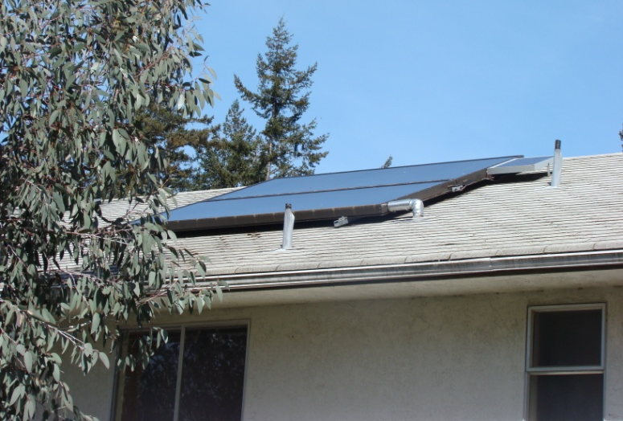
Spreadsheet Directions
The embedded spreadsheet calculates the avoided GHG emissions from multiple solar water heater installations. Recognizing that the performance of installations can vary due to hot water usage, geographical location, and system installation and operating parameters, the spreadsheet includes room to calculate five distinct aggregations of project types. For example, a group of residential homes that have a similar type of solar hot water system installed can be calculated under project type #1, and then the next group with the similar type of solar hot water system installations can be calculated under project type #2 and so on. The directions below lay out the steps for calculating multiple project types.

Step 1: Project name and capacity
Project Name. The spreadsheet includes a series of separate project types to allow for variations in usage, performance, and equipment. | Choose a name common to the project type.
Total Installed Capacity. Calculate the total area of solar collectors for the project type. | Total Installed Capacity (m²) = Total of installed systems * Average area of solar collector (m²)
Step 2: Calculate seasonal average performance
Seasonal average performance of the project type will depend on hot water usage, geographic location, aspect of the system, and system installation and operating parameters. It is recommended that the estimated performance of each installation be provided by the building owner. Otherwise software such as RETScreen can be utilized to calculate a general project average. | In the absence of a project specific average, the spreadsheet contains default performance averages for typical building types (GJ/m²/yr)
Total Water Heating Provided (GJ/yr) | Total Water Heating Provided (GJ/yr) = Seasonal Average Performance (GJ/m²/yr) * Total Area Installed Capacity (m²)
Step 3: Calculate baseline and emission reductions
Displaced Water Heater Average Efficiency. | Calculate the average efficiency of displaced water heaters for each energy type - natural gas, propane, electricity or light fuel oil (%).
Proportion of Energy Sources Displaced. This identifies the proportion of energy types that have been displaced. | 100% = (natural gas systems displaced/total systems) % + (light fuel oil systems displaced/total systems) % + (propane systems displaced/total systems)% + (electricity systems displaced/total systems)%
Calculate Baseline Energy Displaced. | For each energy source calculate:  Energy displaced (GJ/yr) = Total Water Heating Provided (GJ/yr) * proportion energy displaced (%)/Displaced Water Heater average efficiency (%)
GHG emission reduction | GHG avoided (tonnes CO₂e/yr) = (natural gas energy displaced * 0.050 tonnes CO₂e/yr) + (light fuel oil energy displaced * 0.068 tonnes CO₂e/yr) + (electricity energy displaced * 0.003 tonnes CO₂e/yr) + (propane energy displaced * 0.061 tonnes CO₂e/yr)
Step 4: Repeat Steps 1 through 3 for Remaining Project Types
Step 5: Calculate Total Avoided GHG Emissions
Avoided Emissions = Sum of Project Type #1, #2, #3, #4, and #5 emission reductions | Spreadsheet output

Baseline and Project Calculation Guidance
Information Requirements & Sources | Energy type  Water temperature  Hot water demand volume  or  Size and energy rating of hot water heater  Number of building occupants  Number of showers and sinks  - Source: Building owner/manager/tenant  Emission factor for each energy type  - Source: 2017 BC Best Practices Methodology for Quantifying Greenhouse Gas Emissions, https://www2.gov.bc.ca/assets/gov/environment/climate-change/cng/methodology/2017-pso-methodology.pdf
Calculations | Except in rare cases where a building has a meter that monitors energy use from its hot water heater, it will be necessary to use energy modeling software to estimate total energy use over the course of a year. A few software options include:  - Retscreen – Free to register and download. Allows for energy and economic analysis. www.retscreen.net  - CAN-QUEST – Free to register and download. Allows to model energy use in buildings. Many customisable options for advanced users and detailed analysis. https://www.nrcan.gc.ca/energy/efficiency/buildings/20701  - Polysun Solarthermal Simulation – Design tool for solar installation professionals. $2668 to buy. http://www.velasolaris.com/english/product/polysun-designer-und-professional.html  - Transol 3 – Based on the widely used TRNSYS modeling platform. Detailed analysis for system designers and engineers. Approximately $450-$1800 to buy. https://aiguasol.coop/design-of-solar-thermal-systems-with-transol/ ; http://sel.me.wisc.edu/trnsys/features/  After annual energy use is estimated, annual GHG emissions can be calculated:  CO₂e = Total annual energy use x emission factor
Notes | Total baseline emissions should be calculated based on one calendar year of activity
Notes | Total project emissions should be calculated based on one calendar year of activity  Documenting the assumptions used in calculating energy use and GHG emissions for this project will be important, because of the large number of variables involved. The calculation tools listed above provide summary tables of the inputs and outputs that can be used for the purpose of documentation.

Carbon Neutral Framework Compliance
The following checklist outlines seven Project Eligibility Requirements under the Carbon Neutral Framework. Option 1—GCC Supported Projects — are already considered to meet Project Eligibility Requirements three and four below. To demonstrate how an Option 1 project meets the five remaining eligibility requirements, simply complete and make public an Option 1 Project Plan Template (see Appendix 6).
For more information on the project eligibility requirements please refer to section 2.1.1 and Appendix 1 of the Becoming Carbon Neutral guidebook.
Checklist:
- Emission reductions are outside of the local government corporate emissions boundary
- Emission reductions have occurred before they are counted
- Emission reductions are credibly measured
- Emissions reductions are beyond business as usual
- Accounting of emission reductions is transparent
- Emission reductions are only counted once
- Project proponents have clear ownership of all emission reductions
Local Applicability and Cost Factors
- Local Government Role as Project Facilitator: The applicability of this project is dependent on the local government having the capacity to play a facilitation role. Each local government will need to determine an appropriate role to play in the promotion of solar hot water heaters. If a local government owns social housing, then it could directly install or fund the installation of solar thermal systems. Alternatively, the local government could potentially create development permit area guidelines, provide technical assistance, or find other means of helping residents and businesses install solar systems.
- Energy Source Used in Conventional Hot Water Heaters: In some jurisdictions, the norm among developers over the years has been to install electric hot water heaters. Because of the low carbon content of electricity in British Columbia, replacing an electric hot water heater with a solar hot water heater will result in a very small reduction in GHG emissions.
- Project Monitoring and Reporting Effort and Costs: Collecting and reporting data on baseline and project energy use and GHG emissions could present logistical challenges when the buildings are not owned or operated by the local government. This will be the situation in all cases except for government owned social housing projects. The local government will need to identify a mechanism to obtain data necessary to complete the GHG emission reduction calculations (details of the specific data needs are covered in the GHG Accounting Summary section). This may necessitate email, web, telephone or mail-based outreach in combination with social marketing tools to secure the participation of community members / groups and to provide a convenient mechanism for reporting data. For example, an estimate of annual average performance for each installation is required to accurately estimate emission reductions.
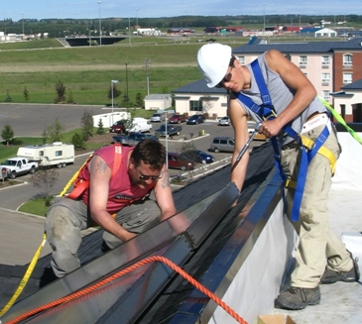
Community and Sustainability
Co-Benefits
Solar hot water systems decrease monthly energy costs through a reduction in natural gas and electricity use and they create local jobs through the demand for new services and expertise.
Precedents
There are many examples of solar hot water projects throughout the Province. These include:
- Schools, Local Governments, Social Housing, Healthcare Facilities, etc. (http://www.bcsea.org/blog/guy-dauncey/2011/02/15/solarbc-shines-across-province)
- The Regional District of Nanaimo’s Green Building Program offers up to $250 for installing solar hot water systems. (https://efficiencybc.ca/incentives/up-to-650-nanaimo-renewable-energy-systems/ )
Project Variations
Other projects that could potentially meet the Carbon Neutral Framework’s criteria with some basic adjustments in the methodology include:
- Solar Thermal Space Heating – There are a variety of technologies and building designs that can be utilized to capture the energy of the sun for building space heating.
- Solar Electricity Generation – Solar photovoltaic (PV) panels can be placed on roofs and walls to generate electricity for in-building use.
- Solar Pool Heating - Glazed and unglazed solar pool systems can reduce gas, oil or propane usage for pool heating
Resources
- CanmetENERGY Performance Directory of Solar Domestic Hot Water Systems: http://www.nrcan.gc.ca/energy/renewable-electricity/solar-thermal/7337
- Solar Rating Online - www.solarrating.ca. Obtain an online assessment of the solar thermal generation potential for your building
- Government of Canada ecoENERGY for Renewable Power program: http://www.ecoaction.gc.ca/ecoenergy-ecoenergie/heat-chauffage/index-eng.cfm
- Vancity Eco-efficiency Loans (Information on receiving a business loan for the installation of solar hot water system): https://www.vancity.com/BusinessBanking/Financing/Loans/EcoEfficiencyLoans/
- United Nation Clean Development Mechanism (CDM) approved methodology for thermal energy carbon credit projects: http://cdm.unfccc.int/methodologies/DB/JSEM51TG3UVKADPA25IPUHXJ85HE8A
- Canadian Solar Industries Association (CanSIA): http://www.cansia.ca/
- Award winning GIS Solar Application that District of North Vancouver has created to help people with assessing the suitability of individual buildings for solar: http://www.geoweb.dnv.org/ (click on applications, and then solar)

